Multilabel-bce
- Binary crossentropy
- Base=resnet50V2, Adam Optimiser (lr=1e-3)
- Dropout 0.3
- Fine tuning for 20 epochs
- Global threshold tuning => best=0.17
- test macro F1 = 0.4569
- test weighted F1= 0.5625
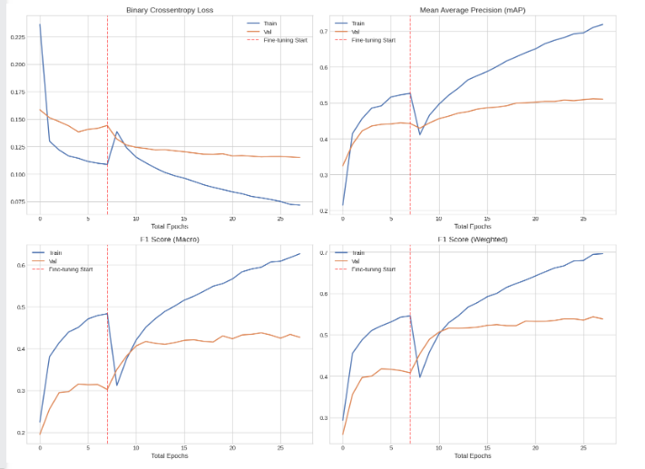
Macro F1 lower than weighted => model is doing worse on rare classes => use a loss that accounts for imbalance
Weighted BCE
- weighted binary cross entropy (class imbalance)
- Resnet50V2, Adam optimiser
- Dropout 0.3
- Fine_tune for 20 epochs
- Best threshold = 0.88
- Test macro f1 = 0.4594
- Test weighted f1 = 0.548
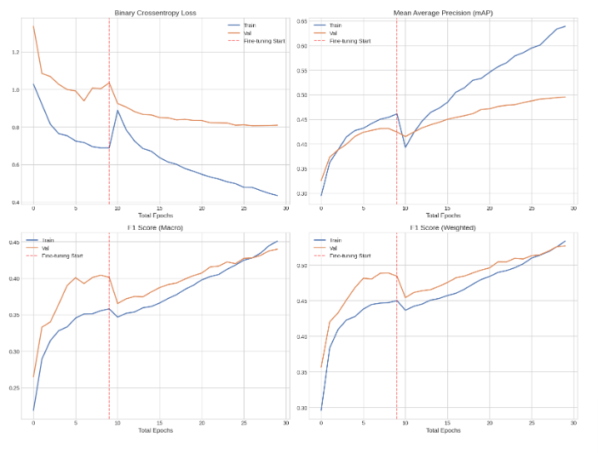
only small gain in macro f1, hurt weighted => try focal loss, to also focus on hard examples

Early stopping on val loss
- Switch from weighted bce to focal loss
Forces loss to 0 past certain point so model only improves on harder cases
- + class dependent alpha tensor to assign more weights to rarer themes
- Base = resnet50V2
- AdamW with weight decay = 1e-4, lr=1e-3
- Dropout 0.3
- Fine tune: add reduce lr on plateau, smaller lr AdamW (lr=5e-5, weight decay=1e-4)
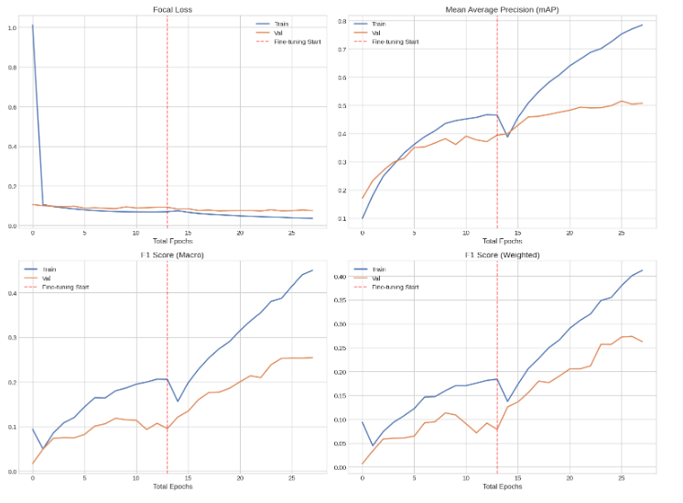
- Best threshold = 0.12
- Test macro f1 = 0.4341
- Test weighted f1 = 0.53
Worse than BCE? Try to fine-tune
Focal loss heavier dropout more epochs
- Focal loss
- Increase dropout from 0.3 to 0.5 (against overfitting, force model to rely on more robust features)
- Increase weight decay to 1e-3 (also reduce overfitting in fine-tune layers)
- Longer training
- Best threshold = 0.12
- Test macro f1: 0.4621
- Test weighted f1: 0.5574
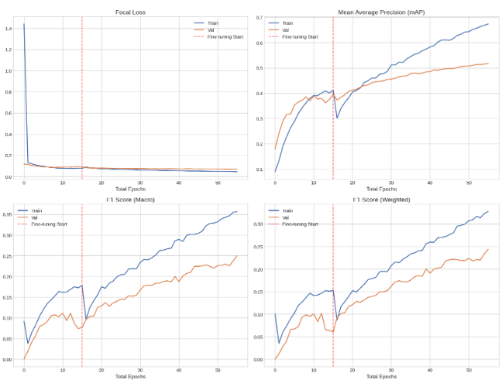
Improved both f1
Focal more epochs cosine decay
- focal loss
- more epochs
- cosine-decay lr schedule with warmup during fine-tuning
- did not work well
- best threshold = 0.12
- macro F1 = 0.4033
- weighted F1 = 0.4957
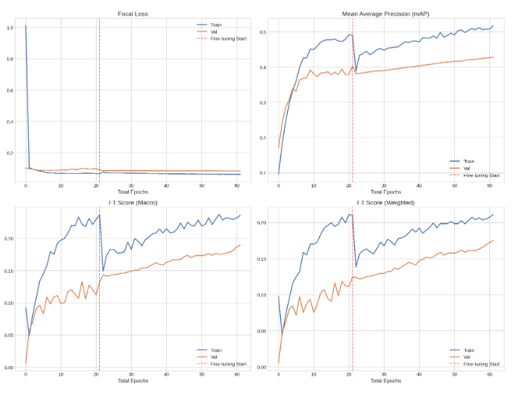
Worse
Focal loss lower weight dec higher ft lr
- focal loss + alpha weights
- adamw, lr=1e-3, lower weight decay: 1e-4
- higher fine-tuning lr: 5e-5
- dropout 0.3
- best threshold = 0.12
- macro f1 = 0.5228
- weighted f1 = 0.5968
- mAP = 0.5321
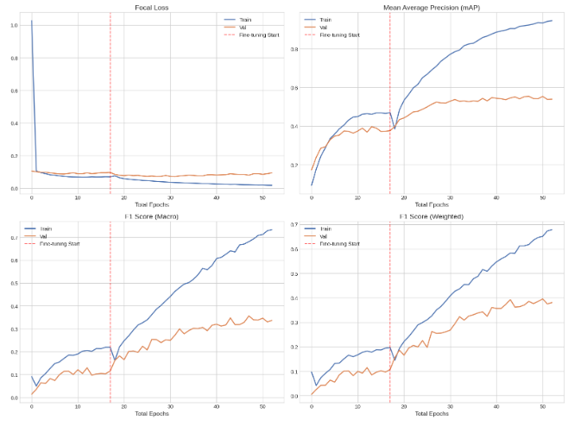
Overfitting => unfreeze fewer layers? No, lower f1 scores
Focal loss w/o alpha tensor
Check if the class weights were helping
- exact same as previous, just no alpha weights in focal loss
- F1 macro = 0.5153
- F1 weighted = 0.607
- mAP = 0.5399
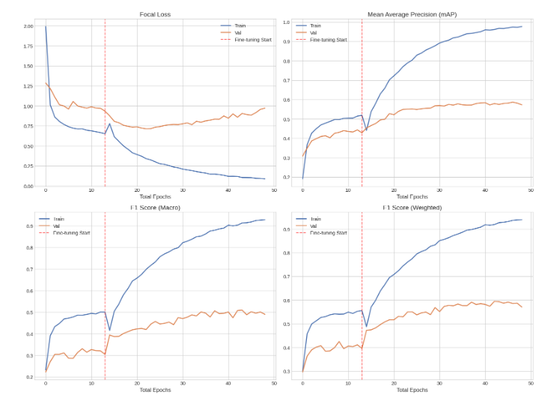
Lower macro f1: alpha weights were helping produce better per-class balance
w/o, model does better on common classes => better overall weighted f1 & mAP

